A group of Scottish Quakers StopEACOPScot have joined an international campaign against **EACOP, the East Africa Crude Oil Pipeline**. Oil wells are being drilled within a national park beside the River Nile in the western part of Uganda. Crude oil will be shipped out through a port in Tanzania. A heated pipeline, 1,443 Km long (the longest in the world, with a cost of – so far - around US$5billion), is being constructed around Lake Victoria, displacing at least 100,000 people who have subsistence lifestyles based on local crops. They are being driven off their land with no realistic compensation. The carbon cost of this project is potentially massive, far exceeding the current carbon footprints of Uganda and Tanzania added together.

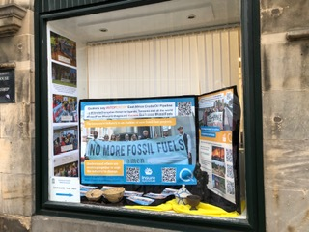

*Edinburgh Central Friends Meeting House window display about STOPEACOP*

StopEACOPScot members have been in touch with local people in Uganda who are bravely protesting at risk to themselves in defence of their environment and their livelihoods: they deserve our support.

The oil company Total is driving the construction phase, but there are also Chinese interests as well as a small contribution from each of Uganda and Tanzania. **We are campaigning to try to persuade insurers and potential investors (such as the Lothian Pension Fund), to commit that they will not invest in Total or insure the EACOP project**.

Email us on [stopeacopscot@gmail.com](mailto:stopeacopscot@gmail.com) to find out what we are doing or join our group.

And … did you know that 25 October -1 November is

[Make Polluters Pay week-of action?](https://makepolluterspay.co.uk/week-of-action?link_id=2&can_id=758886388a0be9e428f62882f5aa46fa&source=email-make-polluters-pay-week-of-action-get-involved-and-tell-the-government-to-step-up&email_referrer=email_2491978&email_subject=make-polluters-pay-week-of-action-get-involved-and-tell-the-government-to-step-up)

Follow the link to find out how you can support this.